Innovative
PORTFOLIO
Unique Design Concepts ..
Creative Living

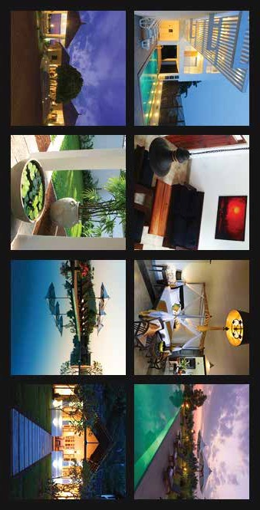


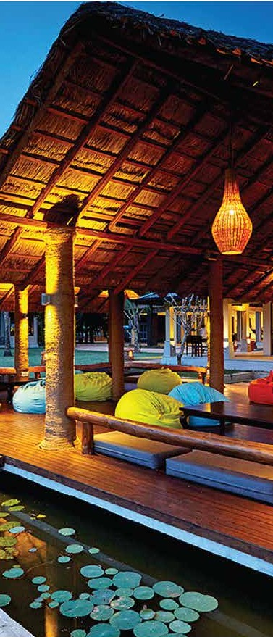
Content
Introduction
Our Vision & Mission Why Choose Us?
Our Services
Residential Interior Design Commercial Interior Design Hospitality & Leisure Design
Custom Furniture & Bespoke Solutions Smart Space Planning & 3D Visualization Renovation & Makeovers
Sustainable & Eco-Friendly Interior Design Turnkey Interior Solutions (End-to-End Services) Landscaping & Outdoor Design
Home Automation & Smart Living Solutions Interior Branding & Concept Development Project Management & Consultation

Introduction
Creative Living is a premier interior design and landscaping ﬁrm specializing in residential, commercial, hospitality, and outdoor spaces. With a commitment to creativity, functionality, and sustainability, we bring design visions to life through innovative concepts and high-quality execution. Our expertise extends from luxury home makeovers to smart ofﬁce designs, eco-friendly landscapes, and high-tech home automation solutions.

Our Vision & Mission Vision
To be a global leader in interior and exterio r design, transforming spaces into ele-gant, functional, and sustainable environments.

Mission
Deliver unique, client-centric interior and landscaping solutions. Integrate smart technology and sustainability into every project. Maintain high-quality craftsmanship and innovative design techniques.
Exceed customer expectations with tailored solutions and seamless execution.

Why Choose Us?
- Expertise in both interior and landscape design.
- End-to-end project management for a hassle-free experience.
- Sustainable and eco-friendly design solutions.
- 3D visualization and smart home integration.
- Custom furniture and branding solutions for businesses.
- Timely execution with quality assurance.

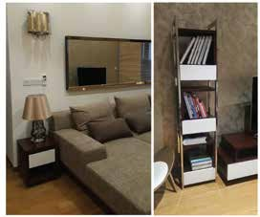
Residential Interior Design
Creating stunning, functional, and luxurious living spaces.
- Luxury Home Interiors – High-end designs with bespoke furniture.
- Modern & Minimalist Spaces – Clean layouts and smart storage solutions.
- Traditional & Heritage Interiors – Timeless aesthetics with rich craftsmanship.
- Apartment & Condo Interiors – Maximizing small spaces with efﬁciency.
- Villa & Penthouse Designs – Grand layouts with customized luxury elements.
- Smart Home Integrations – Automated lighting, security, and temperature control.

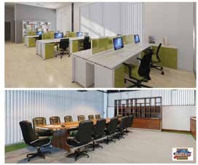
Commercial Interior Design
Enhancing business spaces for productivity and brand identity.
- Corporate Ofﬁce Design – Open workspaces, ergonomic furniture, and premium setups.
- Coworking & Business Hubs – Innovative layouts for dynamic environments.
- Retail Store Interiors – Optimized customer engagement and visual merchandising.
- Showroom & Exhibition Spaces – Strategic layouts for product display.
- Wellness & Healthcare Clinics – Modern, clean, and calming spaces.
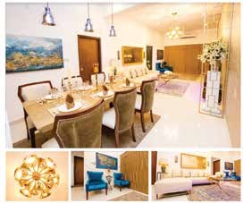
- Banking & Financial Institutions – Professional and secure interiors.

Hospitality & Leisure Design
Crafting immersive experiences through design excellence.
- Hotel & Resort Interiors – Elegant lobbies, guest rooms, and entertainment areas.
- Restaurant & Café Design – Creating ambiance through themed interiors.
- Bars & Nightclubs – Trendy, vibrant, and experience-driven designs.
- Spas & Wellness Centers – Serene and rejuvenating environments.
- Event & Banquet Spaces – Grand setups for special occasions.

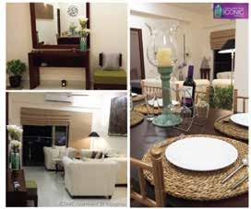
Custom Furniture & Bespoke Solutions
Personalized, high-quality furniture designs tailored to clients’ needs.
- Luxury Custom Furniture – Sofas, beds, tables, and statement pieces.
- Modular & Space-Saving Furniture – Smart storage and convertible designs.
- Ofﬁce & Commercial Furniture – Workstations, ergonomic seating, and conference setups.
- Eco-Friendly & Sustainable Materials – Reclaimed wood and biodegradable elements.

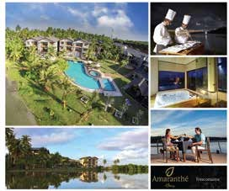
Smart Space Planning & 3D Visualization
Enhancing business spaces for productivity and brand identity.
- Architectural Layout Optimization – Maximizing efﬁciency without compromising aesthetics.
- 3D Rendering & Virtual Walkthroughs – Providing clients with a realistic preview.
- Lighting & Ceiling Design – Custom LED lighting, chandeliers, and false ceilings.
- Flooring & Wall Finishes – Hardwood, marble, feature walls, and decorative wallpapers.

Renovation & Makeovers
Crafting immersive experiences through design excellence.
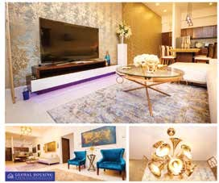
- Home & Apartment Renovations – Updating layouts and interiors.
- Ofﬁce & Commercial Space Revamps – Enhancing business aesthetics and functionality.
- Retail & Hospitality Upgrades – Modernizing spaces for better engagement.
- Historic & Heritage Property Restoration – Preserving and upgrading classic architecture.

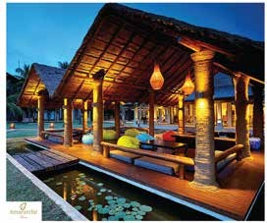
Sustainable & Eco-Friendly Interior Design
- heavy_check_mark: Green Materials & Low-Impact Design – Bamboo, recycled wood, and energy-efﬁcient elements.
- Energy-Saving Lighting & Smart Controls – LED, motion sensors, and solar solutions.
- Biophilic & Indoor Green Spaces – Integrating nature into urban environments.
- Water-Efﬁcient Solutions – Smart plumbing, rainwater harvesting, and ﬁltration systems.

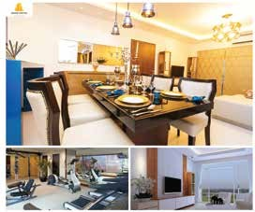
Turnkey Interior Solutions (End-to-End Services)
Enhancing business spaces for productivity and brand identity.
- Concept Development & Design Planning
- Material Sourcing & Procurement
- Project Execution & Quality Control
- Furniture Selection & Customization
- Final Styling & Decor Setup


Landscaping & Outdoor Design
Creating breathtaking outdoor spaces with aesthetic and functional elements.
- Garden & Lawn Design – Sculpted landscapes, decorative plants, and fountains.
- Rooftop & Balcony Gardens – Greening urban spaces.
- Patio & Deck Styling – Outdoor relaxation zones with custom seating.
- Swimming Pools & Water Features – Modern, luxurious outdoor designs.
- Vertical & Indoor Gardens – Sustainable and stylish plant walls.
- Outdoor Furniture & Pergolas – Durable and weather-resistant setups.


Home Automation & Smart Living Solutions
Enhancing convenience and security through technology.
  - Smart Lighting & Climate Control – Automated settings for comfort.
  - Voice-Controlled Home Systems – Integrating Alexa, Google Assistant, and IoT devices.
  - Security & Surveillance – Smart locks, cameras, and motion sensors.
  - Automated Curtains & Blinds – Remote-controlled and scheduled operation.
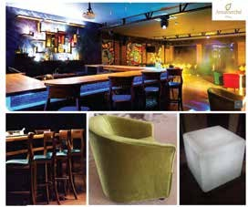
  - Entertainment & Media Rooms – High-tech home theaters and immersive sound.

Interior Branding & Concept Development
Aligning interior spaces with brand identity and customer experience.
- Retail Store Branding & Concepts – Enhancing brand storytelling through design.
- Corporate Identity Integration – Ofﬁce interiors that reﬂect brand values.
- Hospitality Experience Design – Unique identities for hotels and restaurants.
- Color Psychology & Signage Solutions – Incorporating branding into interiors.

Project Management & Consultation
Ensuring seamless execution from concept to completion.
- End-to-End Project Coordination – Managing budgets, timelines, and vendors.
- On-Site Supervision & Quality Control – Monitoring execution standards.
- Vendor & Supplier Management – Collaborating with top suppliers for quality materials.
- Cost & Risk Management – Preventing overruns and optimizing efﬁciency.
- Sustainability Consulting – Advising on eco-conscious construction.

